**Project Research**

For the purposes of the project, I will research one genre so that during meetings I will be able to present ideas from a different angle to the other members of the group, so that discussion is opened and that we can brainstorm a wider range of potential ideas.

The genre that I have chosen is action, as this is a straightforward genre with mechanics that can be interpreted and altered in many ways, compared to more complex genres like strategy that would take too much time to prototype. The website *Kongregate* has many user-made examples of action games, which I will be using for my research.

Out of Nicole Lazzaro’s “4 Keys 2 Fun”, we can immediately discount “people fun” (playing with friends), ( and “easy fun” (exploration and less necessity to reach a goal); the brief specifically details that the product must be a single player game so there is no need for the game to encourage social activity, and the audience for the action genre prefer to get straight into smacking enemies around the screen instead of exploring.

This leaves “hard fun” (the want to overcome a task) and “serious fun” (causes change in the real world). For the latter principle, action games tend to be an outlet for the player to let loose their frustration on a digital punching bag, and for the former principle the player wants to be able to get the best rank for their combo on an enemy. An example of this is “Bayonetta”, an action game that rewards the player higher ranks for beating a certain number of enemies under certain parameters-namely how long they took, how many hits they took, and how many combos they achieved.

On *Kongregate*, the highest rated action games tend to focus on doing the same easy to pick up task repeatedly for a higher score. “*Burrito Bison”*, the highest rated action game, tasks the player with getting the titular character as far as possible by jumping on enemies and collecting power-ups. Other highly-rated games, such as “*Knightmare Tower”* and “*Flight*” also use this type of “catapult” mechanic. Perhaps the popularity of these games can be attributed to their addicting nature; their simplicity encourages the player to keep playing over and over to achieve a higher score. The audience for action genre games tend to find enjoyment in the repetition, as they can fight enemies over and over (or launch a character through the air over and over) without finding it boring.

As a result, it can be asserted that the control of an action game is a major factor to its success. The better the game controls and “flows” from attack to attack, the better it is received by the audience. Taking away a mechanic has previously been done to create the stealth genre of video games, namely “*Metal Gear*” severely limited the way in which players could fight enemies and has since spawned several sequels and imitations. Taking away the ability to fight enemies would create several emotional responses: tension as the player does not want to be seen, frustration if they are caught, and fiero if they managed to sneak by unscathed.

A stealth mechanic would also function well for a single player game, as being isolated would force the player to concentrate more on sounds and their virtual surroundings so that they can plan a route past the enemy better.

Using *Metal Gear* again as an example, the layout of each room is designed so that the player has limited information on the enemy’s patrol patterns but can wait for the enemy to turn around before advancing further through the room and getting a better understanding of how to proceed.

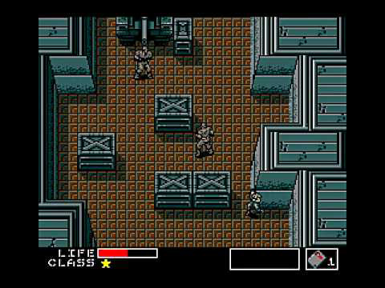

Figure 1 The player, as "Solid Snake" (bottom right) is able to plan ahead before moving as the layout of the room gives them cover from the enemy's line of sight.

Because of the focus on hard fun and single-player challenges present in the “stealth” subset of action, this is the genre that I will brainstorm ideas for going forward as I believe that this is a genre that can be iterated upon very quickly as playtesters will find weaknesses in the enemy’s patrol patterns or the level layouts.

FIGURE 1 SOURCE: Metal Gear Informer <http://www.metalgearinformer.com/?p=29847>